Predicting Task Card #1 | Predicting Task Card #2
1. Look carefully at the picture  2. What do you think will happen next?  3. Why do you think this? | 1. Look carefully at the picture  2. What do you think will happen next?  3. Why do you think this?
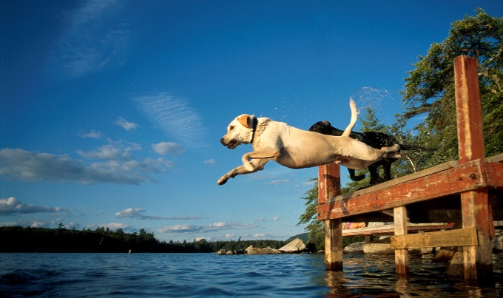 | 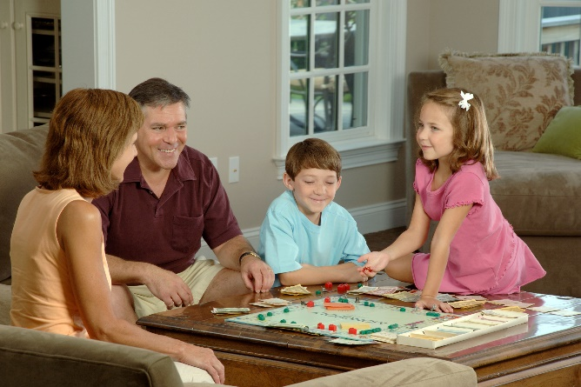
Predicting Task Card #3 | Predicting Task Card #4
1. Look carefully at the picture  2. What do you think will happen next?  3. Why do you think this? | 1. Look carefully at the picture  2. What do you think will happen next?  3. Why do you think this?
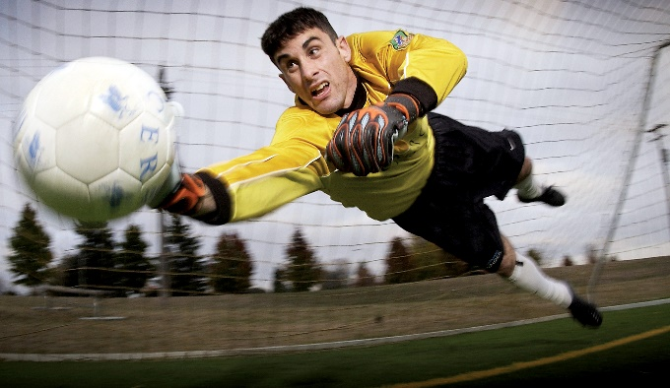 | 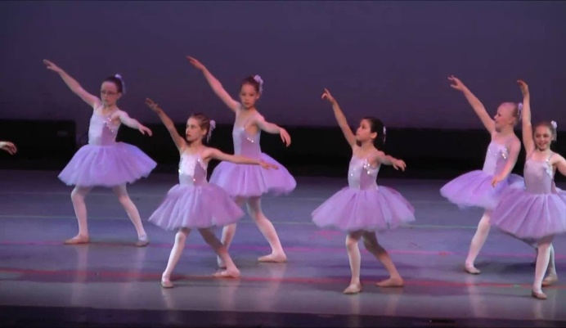
Predicting Task Card #5 | Predicting Task Card #6
1. Look carefully at the picture  2. What do you think will happen next?  3. Why do you think this? | 1. Look carefully at the picture  2. What do you think will happen next?  3. Why do you think this?
