Temporal Touch Card
First touch the mouse then touch the cheese. Touch the cookie jar after you touch the cookie.
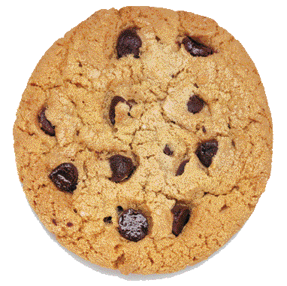 | 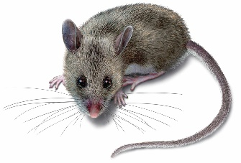 | 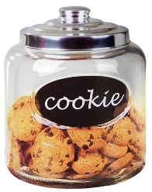 | 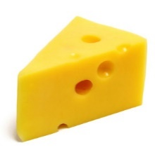
Before you touch the bird touch the nest. Touch the bone after you touch the dog.
 | 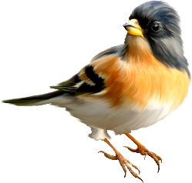 | 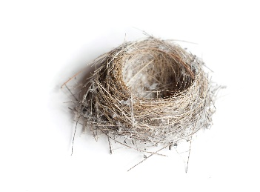 | 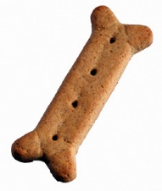
After you touch the fish touch the bowl. Touch the cone before you touch the ice cream.
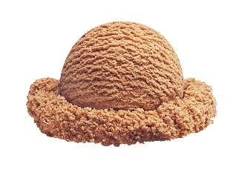 | 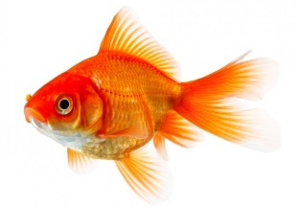 | 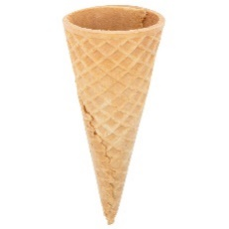
Touch the quarter after you touch the piggy bank. Before you touch the cat touch the cat food.
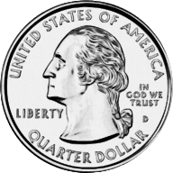 | 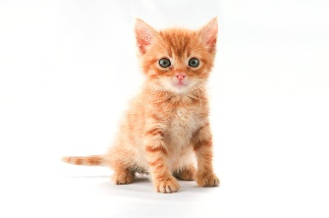 | 