Temporal Touch Card
First touch the rabbit then touch the carrot after you touch the apple after you touch the worm.
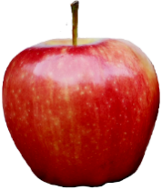 | 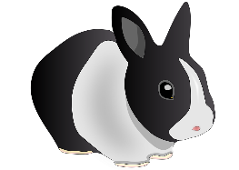 | 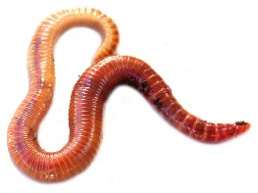 | 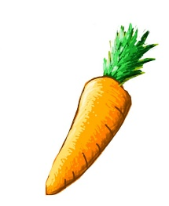
Before you touch the butterfly touch the flower. Touch the tree after you touch the owl.
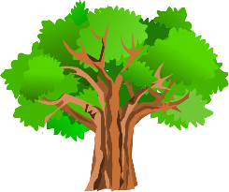 | 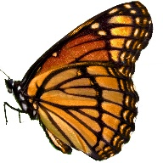 | 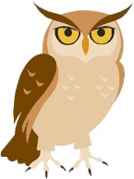 | 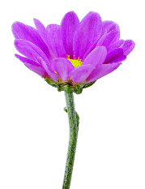
After you touch the cupcake touch the candle. Touch the hand before you touch the pencil
 | 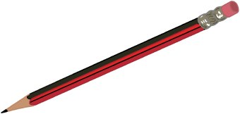 | 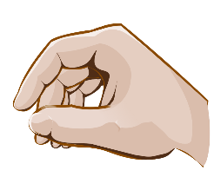 | 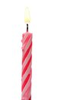
Touch the moon after you touch the sun. Before you touch the monkey touch the banana.
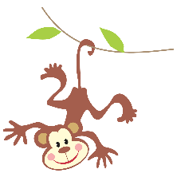 | 