Make Your Own Sundae
First take the cone and add a scoop of mint chocolate chip. After you add the mint chocolate chip scoop to the cone add a chocolate scoop on top. Next add a yellow gummy bear and then a cherry. | First add a vanilla scoop to the green cup with white polka dots. Next add a strawberry scoop on top of the vanilla. Last add a green gummy bear and two cherries.
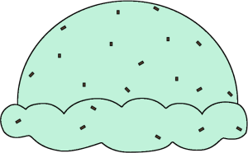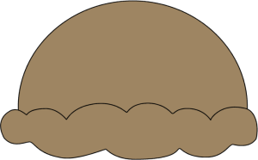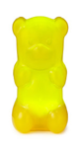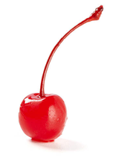 | 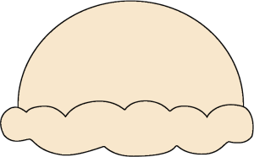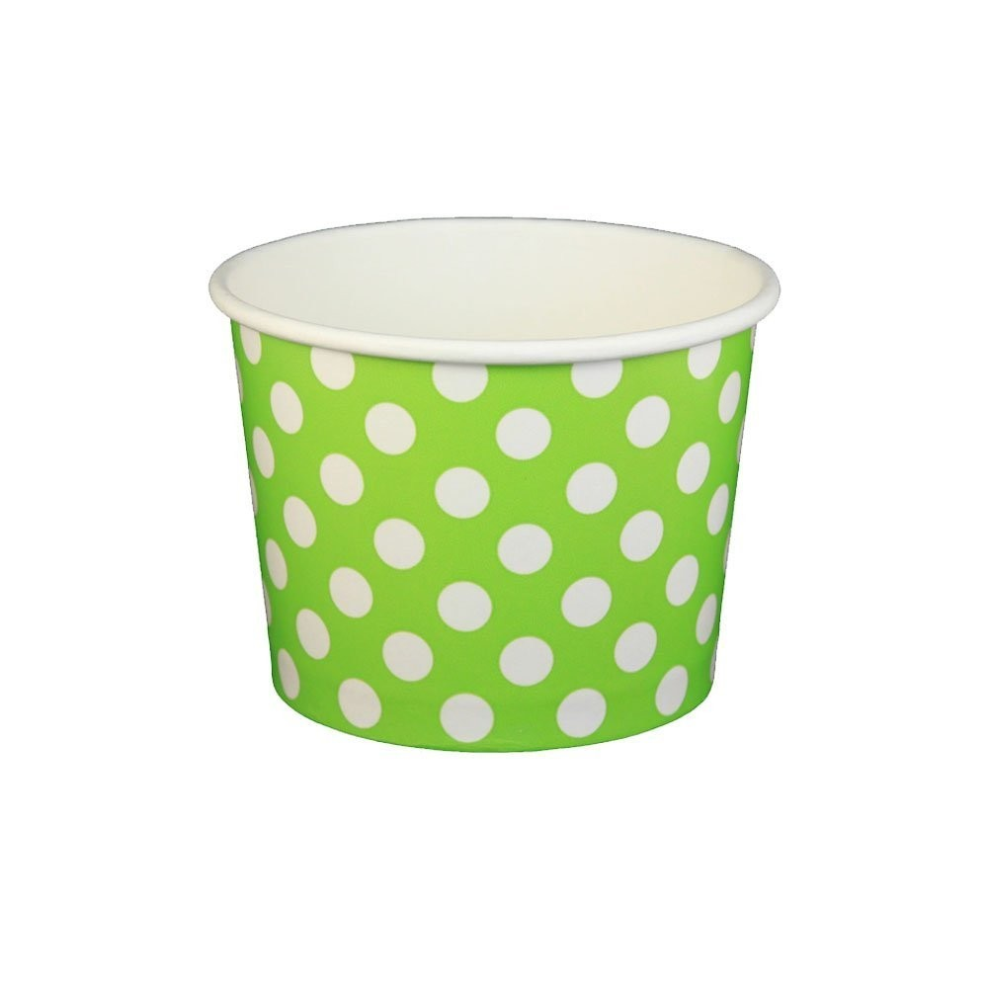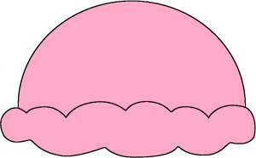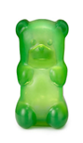
First take the red cup and add a scoop of strawberry then a scoop of chocolate on top. Next add a scoop of vanilla on top of the chocolate. Last take three cherries and put them on top. | After you add the chocolate scoop to the green cup add a scoop of vanilla on top. Next add a yellow gummy bear and then a green gummy bear to the top.
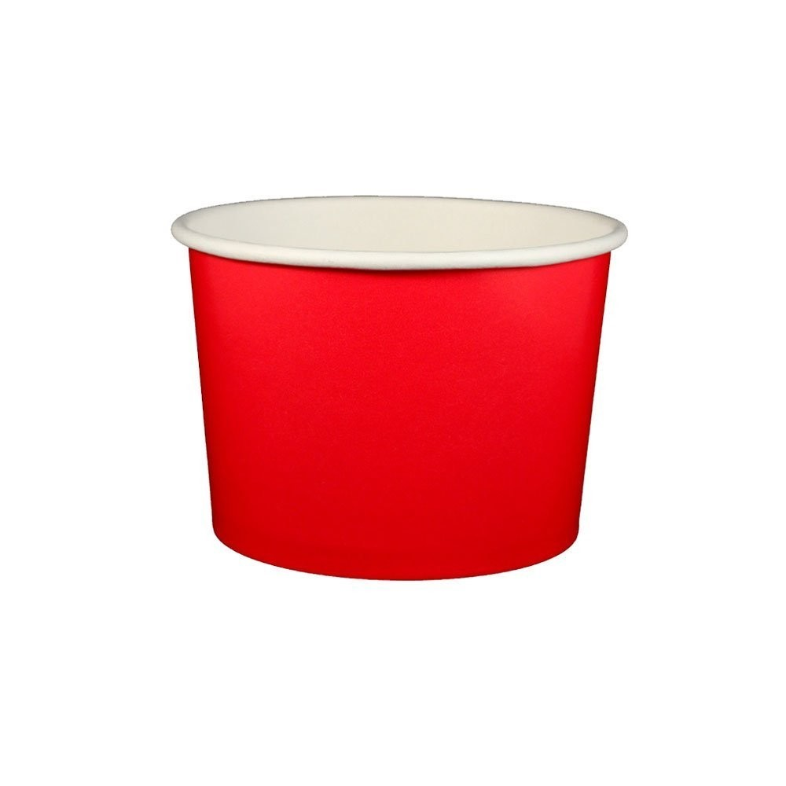 | 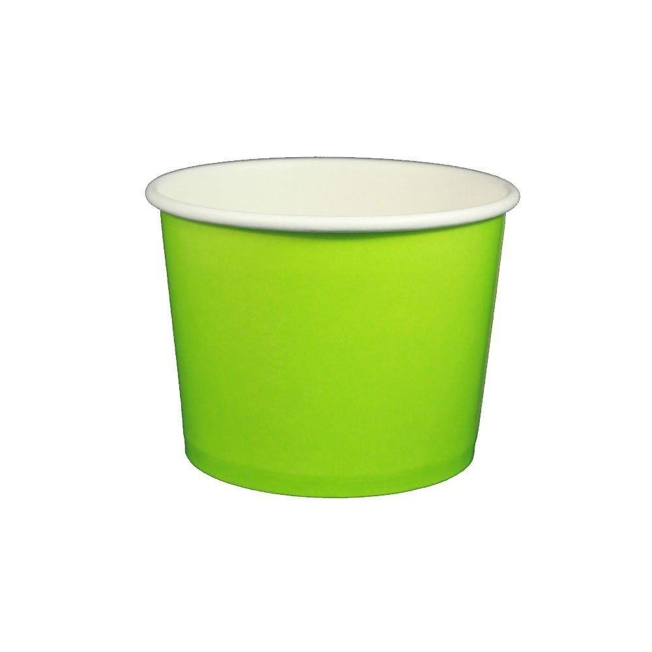
After you add a scoop of strawberry to the cone add a scoop of mint chocolate chip on top. Next add a scoop of vanilla and then add a red gummy bear to the top. | First take the red cup and add a scoop of chocolate. Next add a scoop of strawberry on top. Next put a green gummy bear on top then a red gummy bear next to the green. Top it all off with two cherries.
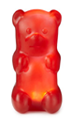

Make Your Own Sundae
First take the green cup with white polka dots and add a scoop of chocolate. After you add the chocolate scoop to the cup add a strawberry scoop on top. Next add a green gummy bear and then a cherry. | First add a strawberry scoop to the cone. Next add a chocolate scoop on top. Last add a yellow gummy bear and two cherries.
First take the cone and add two scoops of chocolate then a scoop of vanilla on top. Last take two cherries and put them on top. | After you add the vanilla scoop to the green cup add a scoop of mint chocolate chip on top. Next add a yellow gummy bear and then a red gummy bear to the top.
After you add a scoop of strawberry to the red cup add a scoop of vanilla on top. Next add a red gummy bear to the top and then add three cherries. | First take the green cup with white polka dots and add a scoop of vanilla. Next add a scoop of mint chocolate chip on top. Next put a green gummy bear on top then top it all off with two cherries.

