How Am I Feeling?

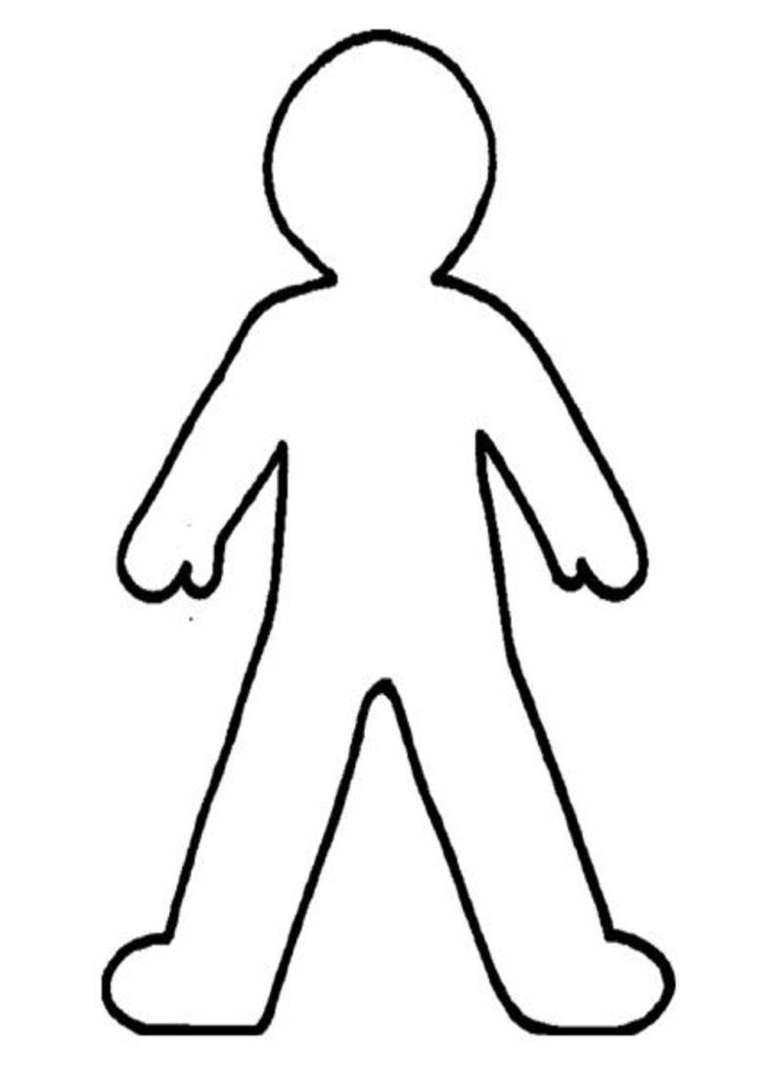 |  |  |  | Hot
 |  |  |  | Tired
 |  |  |  | Hungry
 |  |  |  | Cold
 |  |  |  | Itchy

