Seeing the Forest AND the Trees:

Vision Therapy Infused with Central-Peripheral Integration

Vision Therapist Education
COVD 2016

Philip Bugaiski, OD, FCOVD Michelle Beatty, COVT

Seeing the Forest AND the Trees:
Vision Therapy Infused with Central/Peripheral Integration

Speakers: Philip Bugaiski, OD, FCOVD; Michelle Beatty, COVT

Course Description
What does central/peripheral integration have to do with balance, visual memory, or handwriting? In this hands-on, interactive course, attendees will learn to connect a deeper understanding of central-peripheral integration with optometric vision therapy activities traditionally used for isolated, basic visual skills. Via this deeper understanding, vision therapists will develop more flexibility in the therapy room, allowing patients to integrate their visual skills into effective visual habits for daily living.
After a brief review of the neurological relationship between central and peripheral vision, attendees will watch demonstrations and participate in various therapy activities, with the opportunity for questions and coaching. Materials will be provided so that attendees can easily incorporate new activities into their clinical practice.

Learning Objectives
Participants will be provided the opportunity to:
- Understand that peripheral vision is more than just “side vision”, encompassing three-dimensional space and time,
- Learn observational skills to assess a patient’s peripheral awareness,
- Learn techniques to enhance peripheral awareness during any therapy activity,
- Learn when and how to add distractions, such that patients develop the ability to filter peripheral information while sustaining central attention.

10210 Berkeley Place Drive Suite 200, Charlotte NC 28262
p: 704.510.1555 f: 704.510.2075
7227 Pineville-Matthews Road Suite 400, Charlotte NC 28226
p:704.544.6500 f: 704.554.6502
www.thedvc.net

E.T. Touch

Purpose: To help the patient improve ability to hold his/her eyes still while maintaining peripheral
awareness.

Materials: None

Technique: 1. Sit facing patient.
2. Bring your pointer finger into the patient’s peripheral visual field and stop it there.
3. Instruct the patient to touch your fingertip with his/her fingertip.
(“Like E.T. touched Elliott’s finger in the movie…”)
4. “I wonder if you can keep your eyes on my eyes while you touch my finger.”
5. Give patient feedback appropriate to performance. For example: “Good, you kept
your eyes on mine for a little while, and then you peeked. Let’s try it again…”
6. Repeat with your pointer finger coming from a different starting point
each time.
7. Since self-awareness is a goal of vision therapy, when possible, ask patient, “How
did you do that time?”, etc.

Aspects to be emphasized:
- Patient should have good posture, blink, and breathe normally.
- Patient should be able to maintain eye contact.
- Patient should be able to accurately touch your finger.

Note: This activity is a part of an optometric vision therapy program and is expected to be performed by the patient as instructed by their vision therapist.

10210 Berkeley Place Drive Suite 200, Charlotte NC 28262
p: 704.510.1555 f: 704.510.2075
7227 Pineville-Matthews Road Suite 400, Charlotte NC 28226
p:704.544.6500 f: 704.554.6502
www.thedvc.net

Peripheral Penny Snatch

Purpose: To help the patient improve ability to hold their eyes still while maintaining peripheral
awareness.

Materials: Pennies, plastic cups

Technique: 1. Sit on floor facing patient and put a plastic cup on either side of you.
2. Instruct patient to sit facing you, keep their eyes on your eyes and don’t look away.
3. Take a penny in each hand and pinch between your index finger and thumb holding them just past your shoulders to start.
4. Ask the patient to take the pennies from your fingertips without looking away from your eyes.
Once the patient has successfully taken the penny from the assistant’s fingertip
he/she puts it into the cup while maintaining eye contact. If unsuccessful the patient
must try again.
5. Give patient feedback appropriate to performance. For example: “Good, you kept
your eyes on mine for a little while, and then you peeked. Let’s try it again…”
6. Repeat while holding the penny at a different starting point each time.
7. Since self-awareness is a goal of vision therapy, when possible, ask patient, “How
did you do that time?”, etc.

Aspects to be emphasized:
1. Awareness of maintaining eye contact (Did they peek?) and peripheral vision.
2. Patient should have good posture, blink and breathe normally.
3. Patient’s ability to grab pennies accurately.

Note: This activity is a part of an optometric vision therapy program and is expected to be performed by the patient as instructed by their vision therapist.

10210 Berkeley Place Drive Suite 200, Charlotte NC 28262
p: 704.510.1555 f: 704.510.2075
7227 Pineville-Matthews Road Suite 400, Charlotte NC 28226
p:704.544.6500 f: 704.554.6502
www.thedvc.net

V O Star

Purpose: 1. To learn to control the eyes and hold them still.
2. To learn to process peripheral visual information.
3. To learn to touch targets accurately with and without looking.

Materials: Van Orden Star card

Technique: 1. Place the VO Star at reading distance. Locate and touch each number in order.
2. Keep looking at the central dot. Peripherally locate and touch each number in order,
checking for accuracy. Look at the central dot again before peripherally locating
the next number in order.

Variations: Touch the numbers in reverse order.

Duration: Practice at least 2 minutes per session.

Questions: How do you know where to find the next number? (The lines of the star join the star
points in numbered order.)
Are you able to keep your eyes on the central dot (smiley face)?
Did you notice how concentrating hard on the dot reduces the size and awareness of the
peripheral field of vision? (Look easy at the dot and notice how the periphery opens up.)

Note: This activity is a part of an optometric vision therapy program and is expected to be performed by the patient as instructed by their vision therapist.

10210 Berkeley Place Drive Suite 200, Charlotte NC 28262
p: 704.510.1555 f: 704.510.2075
7227 Pineville-Matthews Road Suite 400, Charlotte NC 28226
p:704.544.6500 f: 704.554.6502
www.thedvc.net

Sherman Numbers

Purpose: 1. To learn to control the eyes and hold them still.
2. To learn to process peripheral visual information.
3. To learn to touch targets accurately with and without looking.

Materials: Sherman Number Card

Technique: 1. Place the card at reading distance. Locate and touch each number in order.
2. Keep looking at the central dot. Peripherally locate and touch each number,
checking for accuracy. Look at the central dot before peripherally locating
the next number in order.

Variations: 1. Use simple addition or subtraction problems and touch each number in the problem
and the answer.
2. Touch all the even or odd numbers in order.

Duration: Practice at least 2 minutes each session.

Questions: Can you figure out the pattern of the number order? (Working from top to bottom, one
number is in each row).
Are you able to keep your eyes on the center dot (smiley face)?
Did you notice how concentrating hard on the dot reduces the size and awareness
of the peripheral field of vision? (Look easy at the dot and notice how the periphery
opens up).

Note: This activity is a part of an optometric vision therapy program and is expected to be performed by the patient as instructed by their vision therapist.

10210 Berkeley Place Drive Suite 200, Charlotte NC 28262
p: 704.510.1555 f: 704.510.2075
7227 Pineville-Matthews Road Suite 400, Charlotte NC 28226
p:704.544.6500 f: 704.554.6502
www.thedvc.net

Lora’s Card

Purpose: To learn to control the eyes and hold them still.
To learn to process peripheral visual information.
To learn to touch targets accurately with and without looking.

Materials: Lora McGraw’s Alphabet Card is made up of all the letters of the alphabet with a central
target. Letters near the center are smaller than those farther from the center.

Technique: 1. Place the card at reading distance. Locate and touch each letter in alphabetical
order.
2. Keep looking at the central dot. Peripherally locate each letter in alphabetical
order. Touch each letter as it is located, and check for accuracy (look at it).
Then look back at the central target before peripherally locating the next letter in order.

Variations: Spell your name, peripherally locating and touching each letter in order.
Spell simple words or practice your spelling list.

Questions: Are you able to keep your eyes on the central dot (smiley face)?
Did you notice how concentrating hard on the dot reduces the size and awareness of
the peripheral field of vision? (Look easy at the dot and notice how the periphery
opens up.)

Note: This activity is a part of an optometric vision therapy program and is expected to be performed by the patient as instructed by their vision therapist.

10210 Berkeley Place Drive Suite 200, Charlotte NC 28262
p: 704.510.1555 f: 704.510.2075
7227 Pineville-Matthews Road Suite 400, Charlotte NC 28226
p:704.544.6500 f: 704.554.6502
www.thedvc.net

Sequential Tracking

Purpose: To help the patient learn to make accurate eye movements, one after another in rhythmic sequence.

Materials: Sequence fixator (provided), metronome or clicker, pointer

Technique: 1. Hold the sequence fixator at the patient’s reading distance. It may be supported
by a book stand or taped to a window for rear illumination.
2. Look at the first target in the upper left corner. Be aware of as much of the
surrounding field of view as possible.
3. Move your eyes from one target to the next along the top line. A pointer may be used
initially for feedback. When you have reached the last target on the right, make the long sweep back to the first target on the left.
4. Repeat the sequence five times, rest for half a minute, then repeat.
Aspects to be emphasized:
1. Strive for both speed and accuracy, but of the two, accuracy is the most important.
2. Eliminate any regressions (looking back at targets already passed over).
3. Maintain a rhythmic shift from target to target. Rhythm is more important than speed.
Begin with the metronome set at a slower speed to master control of the eye movements.
4. Be sure you see each target clearly, and remember to be aware of as much as
possible in your side vision. When you look at one target, are you aware of the next
target?
5. Strive to make each eye movement accurate, speedy, and direct.

Note: This activity is a part of an optometric vision therapy program and is expected to be performed by the patient as instructed by their vision therapist.
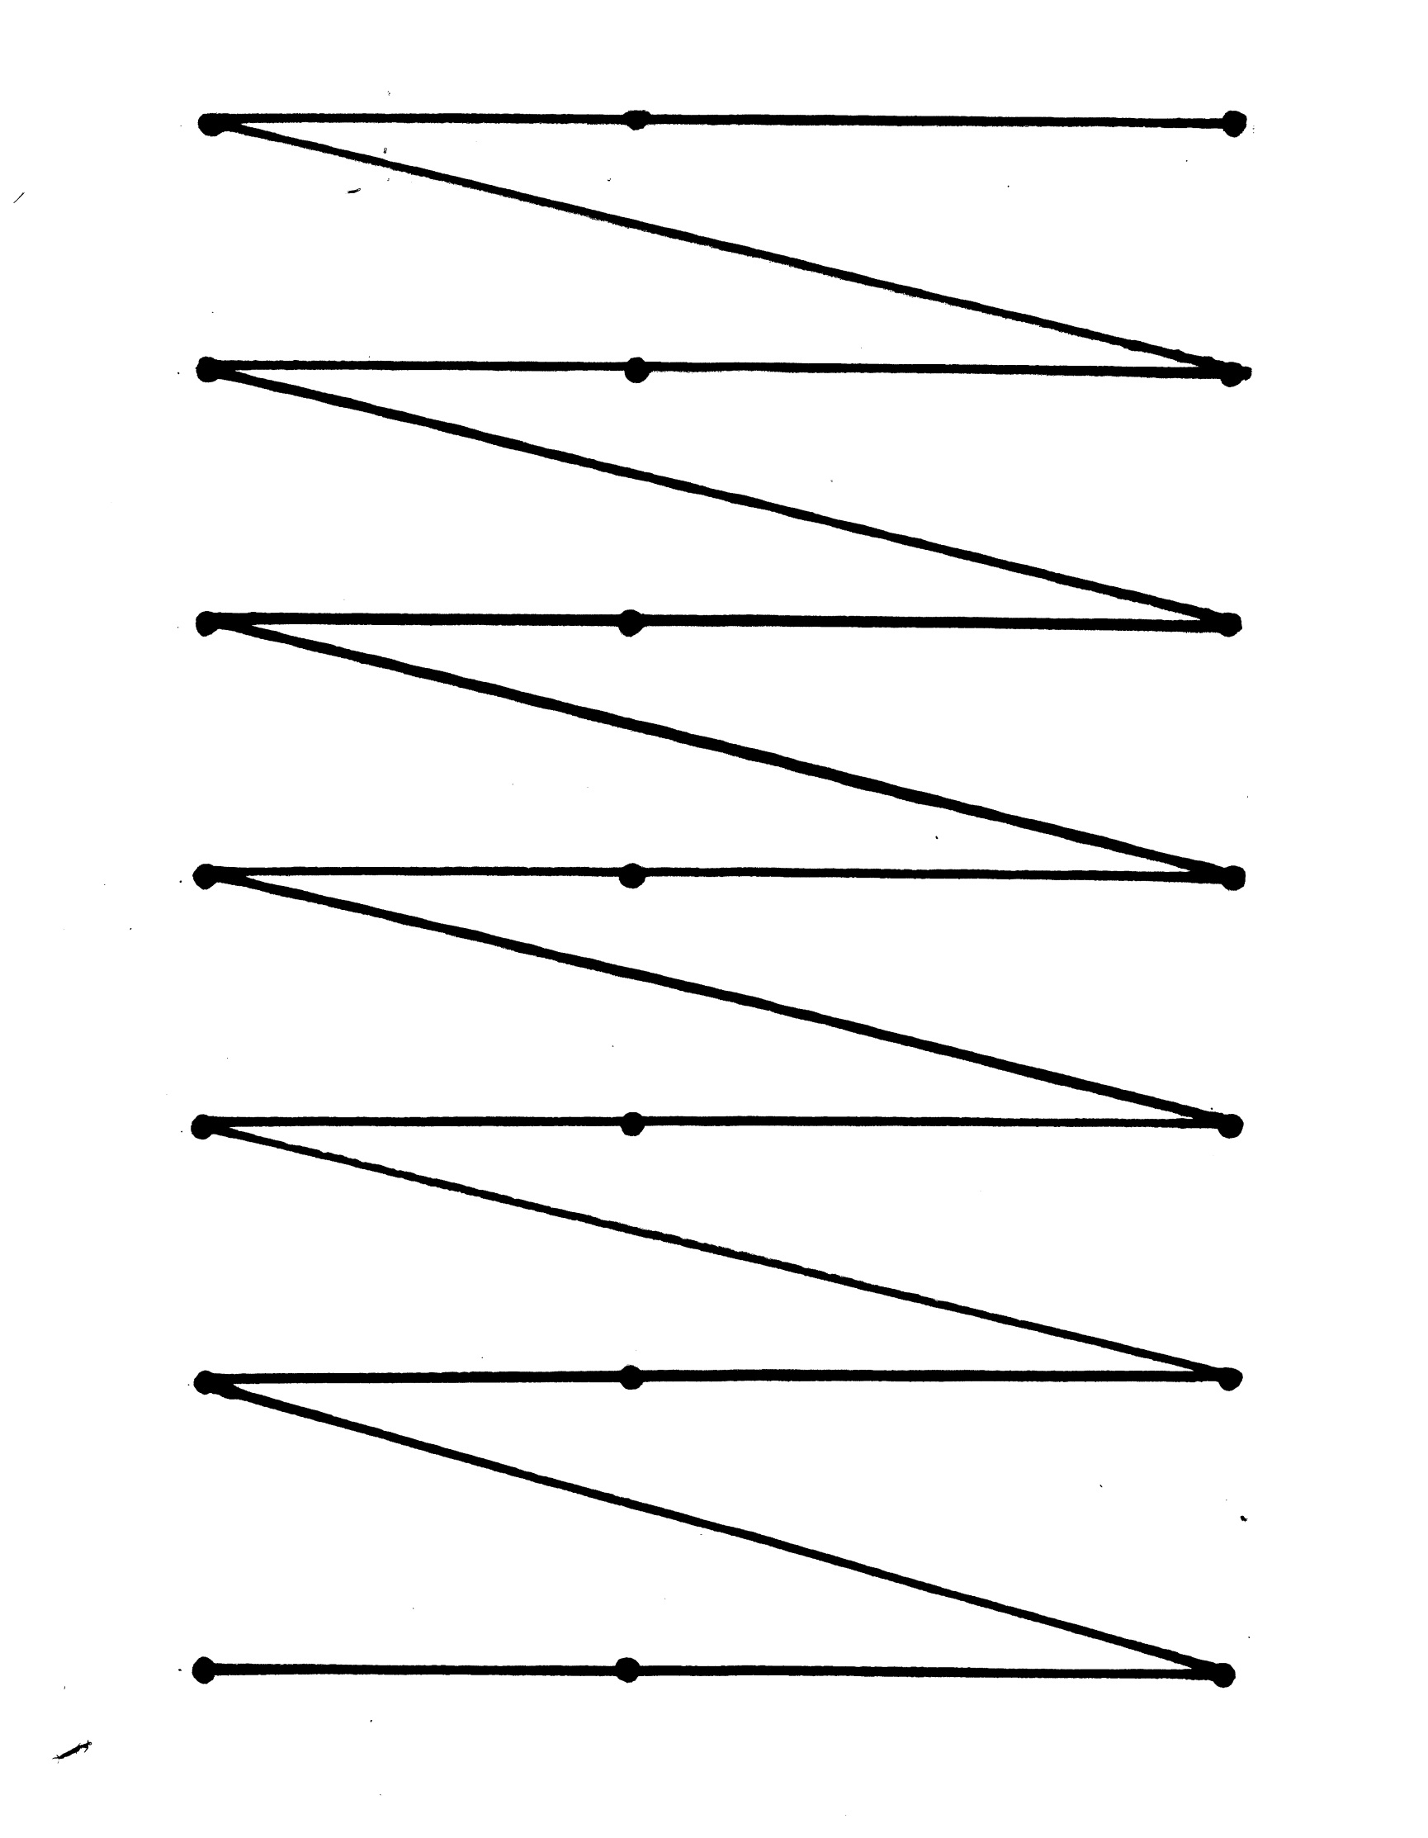
10210 Berkeley Place Drive Suite 200, Charlotte NC 28262
p: 704.510.1555 f: 704.510.2075
7227 Pineville-Matthews Road Suite 400, Charlotte NC 28226
p:704.544.6500 f: 704.554.6502
www.thedvc.net

4 Corners

Purpose: Develop eye aiming ability and control of eye movements

Materials: A wall, window, TV screen, or mirror

Duration: 1-3 minutes

Technique:
- The patient should sit or stand at a distance where he/she can see all four corners of the target by moving their eyes only without any head movement.
- The assistant should sit on the floor facing the patient.
- The assistant gives the instructions; “Look at the upper left corner.” Next, instruct the patient to “keep your eyes on that corner and use your peripheral vision to locate the upper right corner. Wait for the word ‘go’ before moving your eyes to the next corner.” The patient should not move their eyes until a “Go” command is given by the assistant. Give the ‘go’ command and watch the eyes for any inaccurate eye movements. Continue directing the patient to look at the lower right and lower left corners in the same manner.
Variations:
- Direct the patient; “You are now looking at the upper left corner. I want you to move your eyes to the upper right corner but don’t stop there. Keep moving your eyes until you get to the bottom left corner.” Have the patient repeat the instructions before beginning.
- Direct the patient to return their eyes to the original corner after they look away. e.g. “You are now looking at the upper right corner. When I say ‘go’ I want you to look at the lower left corner and then return your eyes to the upper right corner.”
Questions:
- Did your head move?
- Did your eyes move before hearing the “Go” command?
- Could you see the other corners or objects in your peripheral vision while you were looking at a certain corner?
- Could you remember all of the directions when they became complicated?
- Were you able to repeat the directions aloud?
- How did your eyes feel as you did this exercise?
- What parts were hard? Let’s try again!

Note: This activity is a part of an optometric vision therapy program and is expected to be performed by the patient as instructed by their vision therapist.

10210 Berkeley Place Drive Suite 200, Charlotte NC 28262
p: 704.510.1555 f: 704.510.2075
7227 Pineville-Matthews Road Suite 400, Charlotte NC 28226
p:704.544.6500 f: 704.554.6502
www.thedvc.net

Baseball

Purpose: To improve the ability to move your eyes quickly, accurately, and
efficiently from one object to another.

Materials: Nine 3 X 5 cards printed with large numbers from one to nine

Procedure:
- Tape the cards on a wall to form a rectangle approximately 6 X 6 feet as
illustrated below.

1 2 3

4 5 6

7 8 9

- The patient sits or stands at a distance where he/she can see all the numbers.
- The object of the game is to score runs and avoid outs.
A run is scored when the patient succeeds in looking at the numbers from one to nine sequentially without head movement or getting tagged off-base. Outs are made when the patient moves their head or is “off-base”
(not looking steadily at the number until instructed to move.)
- While looking steadily at number one, the patient is to locate number two with their side vision.
- When the Home Assistant calls “number two”, the patient is to shift their eyes quickly and accurately to number two. If they look to any number other than the number called, it constitutes one out and the patient must return to number one. The patient is allowed three outs only.

Aspects to be emphasized:
- Eyes should stay on the number until instructed to move.
- Eye movements should be smooth and efficient.

Note: This activity is a part of an optometric vision therapy program and is expected to be performed by the patient as instructed by their vision therapist.

I10210 Berkeley Place Drive Suite 200, Charlotte NC 28262
p: 704.510.1555 f: 704.510.2075
7227 Pineville-Matthews Road Suite 400, Charlotte NC 28226
p:704.544.6500 f: 704.554.6502
www.thedvc.net

Basketball

Purpose: To help the patient learn to make accurate eye movements, one after another in
rhythmic sequence.

Materials: Letter chart, basketball or playground ball

Technique: 1. Post the chart at eye-level approximately 3-4’ from the patient.
2. The patient is to read the letters left to right while bouncing the ball with both hands.
3. The ball should hit the ground at the same time the letter is said.

Variations: 1.The patient dribbles the ball with the dominant hand.
2. The patient dribbles the ball with the non-dominant hand.
3. The patient alternates between right and left hands.
4. Wall jumps on the letter chart:
-Read the letters in the first and last columns of each row
-Read the letters in the 2nd and 9th columns of each row
-Read the letters in the 3rd and 8th columns of each row
-Read the letters in the 4th and 7th columns of each row
-Read the letters in the 5th and 6th columns of each row
5. Walk-ins on the letter chart:
-Starting with the first row, read in the following order:
1st and 10th letters
2nd and 9th letters
3rd and 8th letters
4th and 7th letters
5th and 6th letters
-Move on to the second row and continue through the chart in the same manner
-Reverse for Walk-outs
Aspects to be emphasized:
Simultaneously bouncing or dribbling the ball while saying the letter on the chart at a
slow, even tempo.

Note: This activity is a part of optometric vision therapy program and is expected to be performed by the patient as instructed by their vision therapist.

Adapted from: How to Use Your Power of Visualization: by Emily Bradley Lyons

Central-Peripheral Self-Assessment

- While directing your attention to a central task, how much do you block out other things in order to attend to that task? Do you become oblivious to your environment?

- Are you inclined to become irritated or frustrated while working on a central task when activities occurring in your periphery cause you to be distracted?

- Do you tend to be so easily distracted by things around you that as you are working on a central project you find a reason for leaving it to do something else?

- Are you able to direct your attention in a near-space situation only if the activity you are doing is intensely interesting to you? While you are doing it, do you tend to “tune out” everything else around you?

- Do you get lost in your own thoughts, even in the midst of a conversation, and tune out people or things around you?

- While maintaining attention on a central task, does awareness of surroundings help your attention or lead to distraction?

- Consider the central-peripheral aspects of some of your favorite leisure activities.

Central-Peripheral Practice

During the break, we will practice central-peripheral flexibility in a social situation, or how to not get lost in space! You will be practicing selective awareness while still remaining conscious of the total situation. As you practice, you will become aware of doing many things at once, and actively using your senses instead of allowing them to work in “automatic mode”.

Choose a category such as: colors, shapes, textures, sounds, movement, or odors. While conversing with someone, become aware of the category you have chosen. For example, become aware of all the colors around you while either conversing or listening without becoming distracted from the conversation. Practice turning on one sense, turning it off while changing to another, and then blending them all together. Adapt these ideas to the social situation you are in, using the idea of expanding your attention.

10210 Berkeley Place Drive Suite 200, Charlotte NC 28262
p: 704.510.1555 f: 704.510.2075
7227 Pineville-Matthews Road Suite 400, Charlotte NC 28226
p:704.544.6500 f: 704.554.6502
www.thedvc.net

Juggling

Purpose: Central/peripheral integration; timing and rhythm

Materials: Scarves, rolled up socks, beanbags, or bags of rice or sand

Technique: 1. Stand relaxed with feet slightly apart, facing a wall at arm’s distance away
with your arms bent at right angles and elbows at sides, palms facing up.
2. Hold one beanbag in your right hand, look at an eye-level target on the wall.
3. Toss the beanbag to your left hand. All tosses should be at eye-level. The count is
“one, catch.”
4. Toss the beanbag back to the right hand and repeat count aloud. Repeat
ten times without dropping.
5. With a beanbag in each hand, begin tossing beanbag #1 from right hand to
left hand. As it starts to drop, make room for it to land by tossing beanbag #2
to your right hand. The count is “one, two, catch.” Repeat ten times without
dropping.
6. Complete this step by starting the sequence with your left hand. Practice
until you can complete ten tosses with each hand without dropping.
7. With beanbags #1 and #3 in your right hand and beanbag #2 in your left hand,
begin by tossing beanbag #1. (The toss always begins with the hand that
holds two beanbags.) As #1 starts to drop, make room for it to land by tossing
beanbag #2. As #2 begins its descent, toss beanbag #3, catching #3 in your
left hand. The count is “one, two, three, catch.” When this sequence is
completed, beanbags #1 and #3 will be in the left hand, and beanbag #2
will be in the right. Now try this sequence another ten times beginning with two
beanbags in left hand and one in the right.

Questions: Are you using your periphery to track the beanbags?

Note: This activity is a part of an optometric vision therapy program and is expected to be
performed by the patient as instructed by their vision therapist.

Appendix:

Sources for materials demonstrated in this session:

V. O. Star OEP
Sherman Numbers OEP
Lora’s Card OEP
MacDonald Form Recognition Field Card OEP
Clock Game from Developing Your Child For Success,
by Kenneth A. Lane, OD Bernell

Descriptions of activities we do in the Vision Therapy Room, but do not send home
for practice, follow.

Marsden Ball Through Quoits

The patient is seated holding a Quoits Vectogram at arm’s length. The Quoits vectogram is set at G. The patient is wearing Polaroid filters. The assistant swings the Marsden ball through the Z axis towards the center of the vectogram. The patient is directed to track the ball looking through the vectogram. What observations does the patient make while tracking the ball?

Minus Lens Exploration

Sitting facing the therapist, the patient occludes one eye with a translucent occluder. Holding a -4.00 diopter lens several inches in front of the uncovered eye, the patient places the lens in a position where he/she can see two images of the therapist’s face. Ask the patient, “How are the two faces different?” Hopefully the patient will discover that one face becomes clear and the other becomes blurry as he/she looks outside or inside the lens, that the face inside the lens appears smaller and closer than the other (SI), that the face outside the lens appears larger and further than the other (LO), and where in space he/she has to look to make each image clear. The patient is asked to, “Tickle my nose with your finger” to help localize each image. Change the power of the lens to help him/her accurately localize the images to assist in learning where to look to clear the lens. Repeat with the other eye.

_____________________________________________________________________

Bulls Eye Rock

The patient stands in a relaxed, balanced posture. A large distance chart is placed on the wall or window at eye level. The patient touches the distance chart and then slowly walks away until he reaches the maximum distance at which he can read the letters clearly.
The patient holds the Bulls Eye card at Harmon distance in front of his right eye (left eye is occluded).The patient views the distance chart through the bulls eye on the clear plastic Bulls Eye card. The patient should be aware that the letters on the distance chart are clear while the bulls eye on the plastic Bulls Eye card is slightly out of focus. If the letters on the distance chart are not clear, then the patient should slowly move closer to the distance chart until they are clear. Instruct the patient to read the first letter on the chart. The patient then shifts his focus to the bulls eye on the plastic Bulls Eye card. It should now come into focus while the letters on the far chart become blurred. The patient continues to shift his focus back and forth between the letters on the distance chart, reading one letter at a time, and the bulls eye on the Bulls Eye card. The patient should gain awareness of the difference in stimulating his focus for the bulls eye target and relaxing his focus back to the distance chart. Strive for quicker focus changes. Repeat for other eye.

Walking Rail Bucket Drop with R/G Hart Chart

The goal of this exercise is to enhance the patient’s ability to use peripheral vision while maintaining balance and tracking a central target. A walking rail is centered in front of a large R/G chart. Large buckets are lined up on either side of the walking rail in a staggered configuration. The patient is given R/G glasses to check for suppression during the activity. He/she starts at the end of the walking rail walking toward the chart calling out the letters or numbers while dropping the beanbags into the buckets using only his/her peripheral vision to locate the buckets.

_____________________________________________________________________

SVI Eye- Hand with Central Fixator On/Central Flash

The goal of this exercise is to enhance the patient’s ability to use their peripheral vision while looking at a central target. Position the patient within arm’s reach of the board, instructing them to keep their head as still as possible and maintain fixation on the central letter. It is important that they maintain this fixation throughout the exercise. As the circles in the periphery appear, he/she is to touch the circle in the center. When the central fixation letter flashes and changes the patient needs to touch the letter before continuing to touch the circles. As the patient becomes more proficient, the speed can be adjusted to make the exercise more challenging.

_____________________________________________________________________

Window Rock

The goal of this exercise is to enhance spatial awareness and visual clarity
Remember to encourage diaphragm breathing (rather than shallow chest breathing). Instruct patient to stand in a relaxed posture and look out the window through +2.00 lens OU for 45 to 60 seconds. Encourage him/her to “relax, enjoy the blur and breathe deeply.” Switch to minus lens OU (power of lens that is challenging for the patient) and present Snellen card to patient asking him/her to begin reading the largest target letters he/she can clear and work up the card to the smallest letters. Repeat… repeat… repeat. Ask the patient to look around without lenses and to share any changes or differences he/she may perceive.

___________________________________________________________

Tach on Wipe Off Board

The patient is standing in front of a dry erase board. An overhead projector is used to briefly flash images onto the board for the patient to recreate once the image is covered by the therapist. The therapist may choose to use shapes, numbers or letters printed on clear transparency film. The stimuli is displayed briefly to the patient and then covered with a piece of opaque paper. The patient is instructed to recreate the forms with the correct pattern, location, size, and spacing between forms.

